भारतमौसमविज्ञानविभाग |  | India Meteorological Department
Saturday, 21st June 2025 (31 Jyeshtha 1947 Saka)
Summary of observations recorded at 0830 hours IST: The Northern Limit of Monsoon continues to pass through 25.0°N/60.0°E, 25.0°N/65.0°E, 25.5°N/70.0°E, Jaipur, Agra, Rampur, Dehradun, Shimla, Manali and 33.5°N/79.0°E. Conditions are favourable for further advance of Southwest monsoon over remaining parts of North Arabian Sea, some more parts of Rajasthan, remaining parts of West Uttar Pradesh, Uttarakhand, Himachal Pradesh and some parts of Jammu & Kashmir-Gilgit-Baltistan-Muzaffarabad, some more parts of Ladakh during next 2 days. Conditions are also becoming favorable for further advance of southwest monsoon over remaining parts of Jammu & Kashmir, Ladakh, some parts of Punjab & Haryana and Chandigarh & Delhi during subsequent 2 days. The low pressure area over south Bihar & neighbourhood lay over southwest Bihar & neighbourhood at 1730 hrs IST of yesterday, the 20th June 2025. It persisted over the same region at 0830 hrs IST of today, the 21st June 2025. The associated upper air cyclonic circulation extended upto 7.6 km above m. s. l. tilting southwards with height also persists. It is likely to move slowly northwestwards and weakened gradually during next 12 hours. The cyclonic circulation over northeast Rajasthan & neighbourhood persisted and extended upto 1.5 km above m. s. l. The trough from northwest Uttar Pradesh to north Gujarat Region ran from northeast Bangladesh to south Gujarat region across cyclonic circulation associated with low pressure area over southwest Bihar and central parts of Madhya Pradesh at 3.1 km above m. s. l. The east-west trough from northwest Rajasthan to Meghalaya ran from central Pakistan to the upper air cyclonic circulation over central Assam across northwest Rajasthan, cyclonic circulation over northeast Rajasthan, north Madhya Pradesh, cyclonic circulation associated with low pressure area over southwest Bihar, Gangetic West Bengal and Meghalaya at 1.5 km above m. s. l. An upper air cyclonic circulation lay over central parts of Assam at 1.5 km above m. s. l.
Day temperatures were markedly above normal (> 5.1°C) at few places over Jammu-Kashmir-Ladakh-Gilgit-Baltistan-Muzaffarabad; at isolated places over Himachal Pradesh. appreciably above normal(3.1°C to 5.0°C) at isolated places over Odisha, Vidarbha, Coastal Andhra Pradesh & Yanam and Tamil Nadu, *Red color warning does not mean "Red Alert" Red color warning means "Take Action" Forecast and warning for any day is valid from 0830 hours IST of day till 0830 hours IST of next day For more details kindly visit https://mausam.imd.gov.in or contact 011-2434-4599 (Service to the nation since 1875) Page 3 Puducherry & Karaikal. above normal (1.6°C to 3.0°C) at many places over Coastal Karnataka; at few places over Telangana and Rayalaseema; at isolated places over Assam & Meghalaya, Konkan & Goa and Kerala & Mahe. near normal (-1.5°C to 1.5°C) at many places over Andaman & Nicobar Islands, Sub Himalayan West Bengal & Sikkim, West Rajasthan, Saurashtra & Kutch and South Interior Karnataka; at most places over Arunachal Pradesh, Nagaland, Manipur, Mizoram & Tripura, Madhya Maharashtra, Marathwada, North Interior Karnataka and Lakshadweep; at few places over Gangetic West Bengal; at isolated places over Bihar, West Uttar Pradesh, Uttarakhand, Punjab, Gujarat Region and Chhattisgarh. The highest maximum temperature of 42.8°C was reported at Sriganganagar (Rajasthan).
The Southwest Monsoon has been active over east Madhya Pradesh. It has been subdued over Rayalaseema.
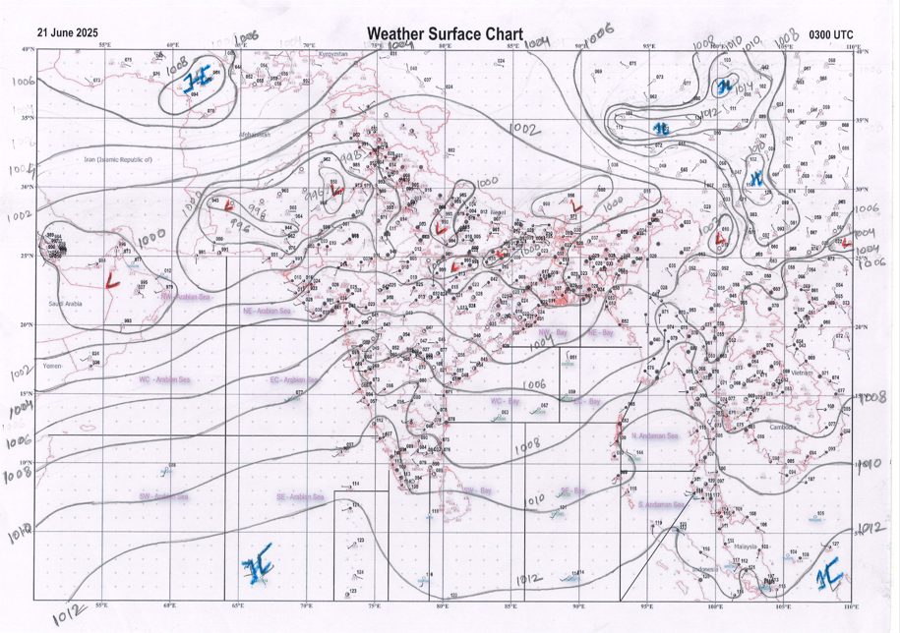 | 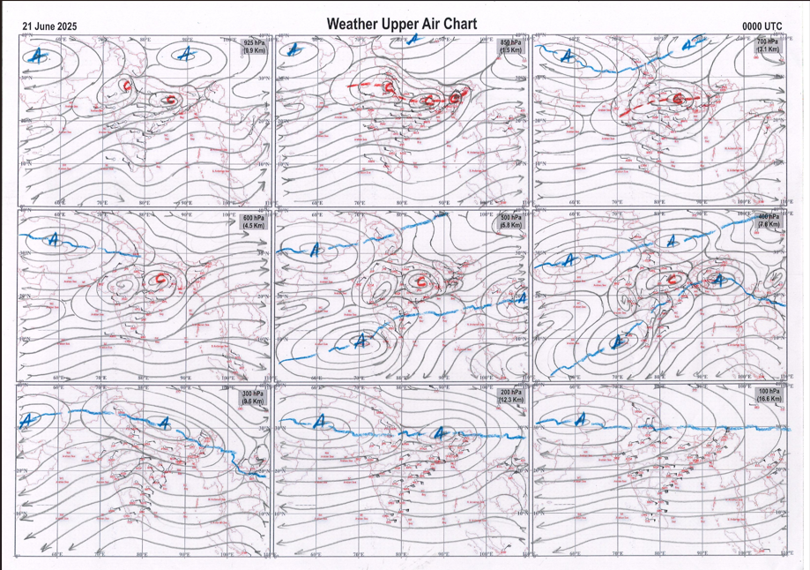
g.1. Analysed surface chart based on 03z observation | Fig.2. Analysed upper air chart based on 00z observation

Dr. Sudeep Kumar B.L.
Scientist ‘D’
CR & S Office, Pune  Issued at 1245 hrs. IST |  | Weather Forecasting Division  CR&S, Pune

Indian regions | Realised rainfall (chief amount in cm during past 24 hrs):
East | many places: Arunachal Pradesh, Nagaland-Manipur-Mizoram-Tripura, Jharkhand+ and Bihar+  a few places: Assam & Meghalaya+ and Sub-Himalayan West Bengal & Sikkim  isolated places: Gangetic West Bengal and Odisha  Barkagaon & Jaganathpur bau kvk AWS 8.5 each, Mawsynram 8.2, Cherrapunji 7.9, Chauldhowaghat 7.5, Garhi 7.1, Jiribam AWS 6.3, Kochas 6.2, Deomali AWS 6.1, Sabroom 5.4, Basar AWS 4.7, Daltonganj 4.0, Purnea 3.5, Pasighat AP & Rongo 3.0 each, Sukiapokhri 2.5, Kutra 2.3, Imphal AP & Balurghat 1.2 each, Mandira dam 1.1, Luchipur 0.7, Mangalkote 0.6, Asansol (CWC) 0.5, Sundargarh 0.4.
North | many places: east Rajasthan+++  a few places: east Uttar Pradesh+++, west Uttar Pradesh+, Uttarakhand+, Himachal Pradesh+ and west Rajasthan+  isolated places: Haryana, Punjab+ and Jammu-Kashmir and Ladakh+  Niwai 16.5, Chaksu 15.3, Ghorawal 13.6, Bundi 11.6, Shahpur kandi 11.3, Bhinga 11.0, Kangra AP 8.8, Narendranagar 8.1, Jhansi 7.6, Kathua ARG 7.5, Madhopur 7.0, Bhopalgarh SR 6.5, Samba AWS 6.4, Kathua 6.3, Prayagraj PBO 6.2, Nagrota surian 5.6, Haripur & Makrana SR 4.6 each, Agra (CWC) 4.0, Etawah 3.9, Nagaur tehsil SR 2.2, Nahan 1.8, Uttar kashi 1.0, Jhirka 0.7, Delhi ridge 0.6, Chandigarh 0.5, Amritsar 0.4.
Central | many places: east Madhya Pradesh+++  a few places: west Madhya Pradesh+++ and Chhattisgarh+  isolated places: Vidarbha  Kathiwada 18.7, Bhabhra 16.8, Sihawal 11.6, Surajpur 11.5, Patna 9.3, Hanumana 8.8, Alirajpur 7.6, Tikamgarh-aws 4.2, Ambikapur 4.0, Bhamragad 1.7, Korpana 0.5, Bramhapuri 0.1.
Peninsula | most places: Konkan & Goa+, coastal Karnataka+ and Kerala  a few places: Gujarat Region#, Madhya Maharashtra+++ and interior Karnataka  isolated places: Saurashtra & Kutch, Marathwada, coastal Andhra Pradesh, Telangana, Rayalaseema and Tamil Nadu  Jambughoda 20.5, Jetpur pavi 12.9, Radhanagari 11.6, Dahanu 8.3, Shahuwadi 8.2, Sawantwadi 7.8, Mahabaleshwar 7.3, Kadra 6.9, Sangameshwar devrukh 6.8, Agumbe emo 5.7, Castle rock 5.1, Khanapur 4.9, V.vidyanagar SR, Chuda, Srisailam & Udumbannoor AWS 4.1 each, Sandhiyur kvk AWS 3.9, Mangalapuram & Thodupuzha 3.8 each, Bhagamandala 3.3, Rajahmundry & Kammardi 3.1 each, Alur & Belagavi PTO 2.8 each, Kottayam 2.7, Julurpad 2.6, Valparai PTO 2.5, Dowleshwaram & Pebbair 2.1 each, Bhadrachalam 1.8, Londa 1.5.
Islands | most places: Andaman & Nicobar  a few places: Lakshadweep  Maya bandar 6.1, Port blair 5.6, Long island 4.1, Agathi 0.7, Minicoy 0.1.
Table 2. Forecast / warnings (distribution of rain / thundershowers) for 7 days (valid from time of origin upto 0830 hrs IST of next day)
Sr N. |  | Sub-division Name | Day 1 | Day 2 | Day 3 | Day 4 | Day 5 | Day 6 | Day 7 | Sr. No. | Sub-division Name | Day 1 | Day 2 | Day 3 | Day 4 | Day 5 | Day 6 | Day 7
 |  |  | 21 Jun | 22 Jun | 23 Jun | 24 Jun | 25 Jun | 26 Jun | 27 Jun |  |  | 21 Jun | 22 Jun | 23 Jun | 24 Jun | 25 Jun | 26 Jun | 27 Jun
 | 1 | Andaman Nicobar Islands | W +  | W +  | W  | W  | W  | W | W  | 19 | west Madhya Pradesh | W ++  | W ++ | W # | W ++ | W ++ | W + | W ++
 | 2 | Arunachal Pradesh | F +  | W +  | W ++  | W +  | F +  | F | F +  | 20 | east Madhya Pradesh | W ++  | W ++  | W # | W ++  | W ++  | W + | W ++ 
 | 3 | Assam-Meghalaya | W ++  | W ++  | W ++  | F +  | F +  | F + | F +  | 21 | Gujarat region | W #  | W ++ | W ++ | W++ | W++ | F ++ | W ++ 
 | 4 | Nagaland-Manipur-Mizoram-Tripura | W +  | W ++  | W ++  | W ++  | F +  | F + | F +  | 22 | Saurashtra and Kutch | W ++  | W ++ | W++ | F ++ | F ++ | F ++ | F ++ 
 | 5 | Sub Himalayan West Bengal/Sikkim | F +  | W ++ | W +  | F +  | F  | F | F  | 23 | Konkan and Goa | W +  | W ++  | W ++  | W ++  | W ++  | W ++ | W ++
 | 6 | Gangetic West Bengal | S | F +  | W  | W + | W + | W + | F + | 24 | Madhya Maharashtra | S + | S ++ | F ++ | F ++ | S ++ | F ++ | F ++
 | 7 | Odisha | I  | S  | S  | F +  | F +  | W | W + | 25 | Marathwada | I  | I | I | I | I | I | I
 | 8 | Jharkhand | F  | F +  | W  | W +  | W +  | W | F +  | 26 | Vidarbha | I  | I  | I  | S +  | F +  | F + | F + 
 | 9 | Bihar | F +  | F +  | F +  | F ++ | S  | S  | S  | 27 | Chhattisgarh | S +  | S  | S  | F ++  | W +  | W + | F + 
 | 10 | east Uttar Pradesh | F +  | W ++ | W ++ | W + | F  | S  | S  | 28 | Coastal Andhra Pradesh and Yanam | I  + | I + | I + | S  + | S  | I | I 
 | 11 | west Uttar Pradesh | S + | F ++ | W ++ | F + | F  | S  | S  | 29 | Telangana | I  | I  | I  | I  | I  | I | I 
 | 12 | Uttarakhand | F +  | W++  | W++  | W +  | W ++ | W+  | F++  | 30 | Rayalaseema | I + | I + | I + | I + | I | I | I
 | 13 | Haryana,Chandigarh and Delhi | S +  | W ++  | W +  | S +  | F +  | F +  | S +  | 31 | Tamil Nadu, Puducherry and Karaikal | I  + | I  + | I | I | I | I | I
 | 14 | Punjab | S +  | W ++  | F +  | S +  | F ++  | F +  | S ++  | 32 | Coastal Karnataka | W  | W+  | W+ | W+  | W+  | W | W+ 
 | 15 | Himachal Pradesh | F + | W ++ | W + | F + | W ++ | W ++ | F ++ | 33 | North interior Karnataka | I  | I  | I  | I  | I  | I | S 
 | 16 | Jammu-Kashmir and Ladakh | S +  | W +  | S+  | S +  | W++ | W+  | W++ | 34 | South interior Karnataka | I  | I  | I +  | I +  | S+  | S | S + 
 | 17 | west Rajasthan | S +  | I  | I  | I  | I  | S  | S  | 35 | Kerala and Mahe | W | W + | W + | W + | W + | W + | W +
 | 18 | east Rajasthan | F++  | S++  | F ++  | S +  | S+  | F ++ | F +  | 36 | Lakshadweep | W | W | W | W | W | W | W
Legends: D = Dry I = Isolated S = Scattered F = Fairly widespread W = Widespread #= heavy to very heavy rain at a few places with extremely heavy rain at isolated places +++= heavy rain at a few places with very heavy rain at Isolated places ++= heavy to very heavy rainfall @=Isolated exceptionally heavy rainfall + = heavy rain ●/*= rain or snow ♦ = very light rain ≡=fog= thunderstorm with lightning =Squall / Gusty / gale / strong wind ­ =cold wave/cold day += heat wave/warm night/hot and humid weathe r=Duststorm =ground frost = Hail

Fig. 4: Districtwise warnings for five days for Maharashtra State
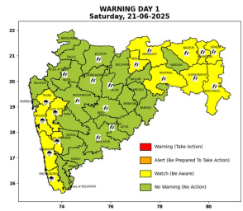 | 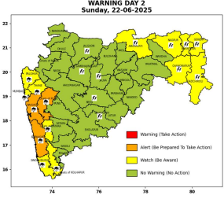 | 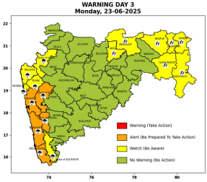 | 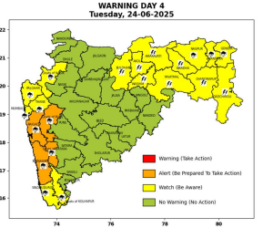 | 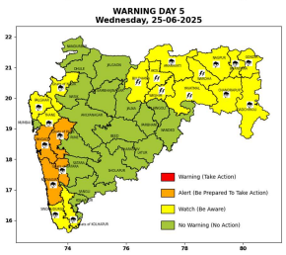

Pune, Lohegaon and Pashan observations at 0830 hrs. IST of Today
 | Temperature (°C) |  |  |  |  | Humidity (%) |  |  |  | Rainfall (mm)
 | Max.  past  24 hrs | Dep.  from  normal | Min.  past  24 hrs. | Dep.  from  normal | Dry  Bulb | At 0830 hrs. IST | Dep.  From  normal | At 1730  hrs. IST of y’day | Dep.  from  normal | Past  24 hrs. | Since  1st June | Dep.  from  normal
PNE | 28.6 | -1.8 | 22.9 | -0.1 | 24.4 | 89 | 11 | 74 | 4 | 2.6 | 238.2 | 132.2
PSN | 27.2 | - |  | - |  |  | - |  | - |  |  | -
LHG | 30.4 | -0.6 | 24.5 | 3.5 | 26.5 | 77 | -1 | 63 | -2 | 0.4 | 230.6 | 162.9

 |  |  |  |  |  |  | Local (Pune and neighbourhood) forecast
Max./Min. Temperature (°C) |  |  |  |  |  |  |  |  | Weather
Date | Pune | Pashan | Lohegaon | Chinchwad | Lavale | Magarpatta | NDA | Koregoan Park
21/06/25 | 29 / 22.9* | 28 /-- | 30 / 24.5* | 29 / 23.6* | 28 / 22.5* | 30 / 24.2* | 28 / 23.1* | 29 / 24.0* | Generally cloudy sky. Light rain very likely.
22/06/25 | 27 / 23 | 26 / 23 | 28 / 25 | 28 / 24 | 26 / 23 | 29 / 24 | 27 / 23 | 28 / 24 | Generally cloudy sky. a few spells of light to moderate rain very likely.
23/06/25 | 27 / 23 | 26 / 23 | 28 / 25 | 28 / 24 | 26 / 23 | 29 / 24 | 27 / 23 | 28 / 24 | Generally cloudy sky. a few spells of light to moderate rain very likely.
24/06/25 | 27 / 22 | 26 / 22 | 28 / 24 | 28 / 23 | 26 / 22 | 29 / 23 | 27 / 22 | 28 / 23 | Generally cloudy sky. a few spells of light to moderate rain very likely.
25/06/25 | 28 / 22 | 27 / 22 | 29 / 24 | 29 / 23 | 27 / 22 | 30 / 23 | 28 / 22 | 29 / 23 | Generally cloudy sky. Light rain very likely.
26/06/25 | 28 / 23 | 27 / 23 | 29 / 25 | 29 / 24 | 27 / 23 | 30 / 24 | 28 / 23 | 29 / 24 | Generally cloudy sky. Light rain very likely.
27/06/25 | 28 / 23 | 27 / 23 | 29 / 25 | 29 / 24 | 27 / 23 | 30 / 24 | 28 / 23 | 29 / 24 | Generally cloudy sky. Light rain very likely.
Rainfall Distribution |  |  | Rainfall Categories | Rainfall (mm) |  | Cloud condition |  |  |  | Rainfall Intensity |  | Range
Widespread (W) | 76-100% |  | Very Light rain | Trace to 2.4 mm |  | Mainly clear sky |  | 1-2 oktas |  | Light Spell |  | 1 cm/hr
 |  |  | Light rain | 2.5 to 15.5 mm |  | Partly cloudy sky |  | 3-4 oktas |  | Moderate Spell |  | 1-2 cm/hr
Fairly Widespread (FW) | 51 – 75% |  | Moderate rain | 15.6 to 64.4 mm |  | Generally cloudy sky |  | 5-7 oktas |  | Intense Spell |  | 2-3 cm/hr
Scattered (S) | 26 – 50% |  | Heavy rain | 64.5 to 115.5 mm |  | Overcast |  | 8 oktas |  | Very Intense Spell |  | 3-5 cm/hr
isolated (I) | 1 – 25% |  | Very heavy rain | 115.6 to 204.4 mm |  |  |  |  |  | Extremely Intense Spell |  | 5-10 cm/hr
D (D) | No Rain |  | Extremely heavy rain | ≥ 204.5 mm |  |  |  |  |  | Cloudburst |  | > 10 cm/hr
Probability Terms in %: |  |  | Heavy snow | 6.5 to 11.5 cms water equivalent of rain
unlikely | < 25 |  | Very heavy snow | 11.6 to 20.4 cms water equivalent of rain
likely | between 25 50
very likely | between 51 75
most likely | >75
* = realized temperature
Mumbai (Colaba) |  |  |  | Nagpur (AP)
Date 2025 | T max °C | T min °C | Weather | T max °C | T min °C | Weather
21/06 | 31 | 27 | Generally cloudy sky with intermittent. | 38 | 27 | Generally cloudy sky with a few spells of rain or thundershowers accompanied with Lightning.
22/06 | 31 | 26 | Generally cloudy sky with intermittent heavy rainfall. | 38 | 27 | Generally cloudy sky with a few spells of rain or thundershowers accompanied with Lightning.
23/06 | 32 | 26 | Generally cloudy sky with intermittent heavy rainfall. | 38 | 27 | Generally cloudy sky with a few spells of rain or thundershowers accompanied with Lightning.
24/06 | 32 | 26 | Generally cloudy sky with intermittent rain. | 37 | 27 | Generally cloudy sky with a few spells of rain or thundershowers accompanied with Lightning.
25/06 | 31 | 26 | Generally cloudy sky with intermittent rain. | 36 | 27 | Generally cloudy sky with a few spells of rain or thundershowers accompanied with Lightning.
26/06 | 31 | 27 | Rain. | 34 | 26 | Generally cloudy sky with a few spells of rain or thunderstorm.
27/06 | 30 | 27 | Rain. | 35 | 25 | Generally cloudy sky with a few spells of rain or thunderstorm.

